

**Instructions to update the units**

Ⅰ.**Hardware and software needed**

1. Device driver for the USB adapter

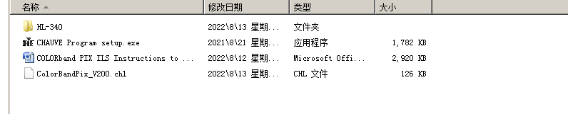

2. ISP Software which is used to updated the program

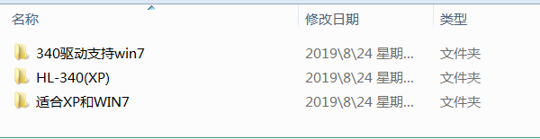

3. Flash program

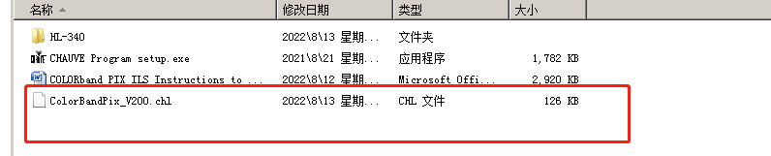

4.USB uploader

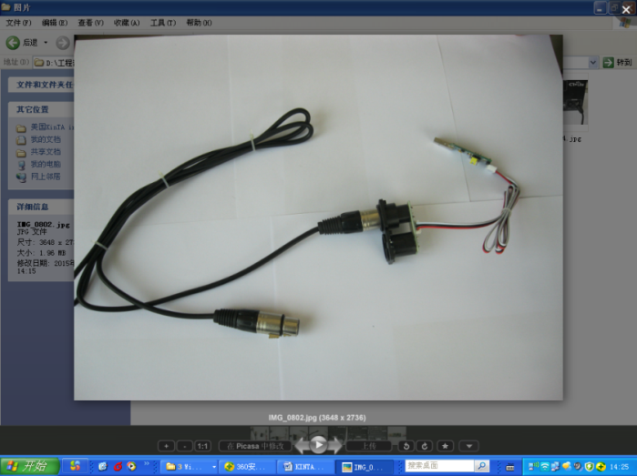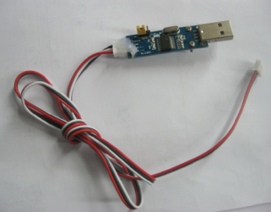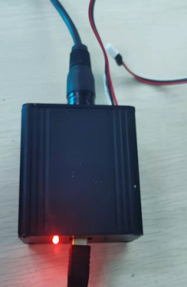

**Ⅲ.Install the device driver for the USB uploader**

1. Open the folder (device driver)



1. select the setup file

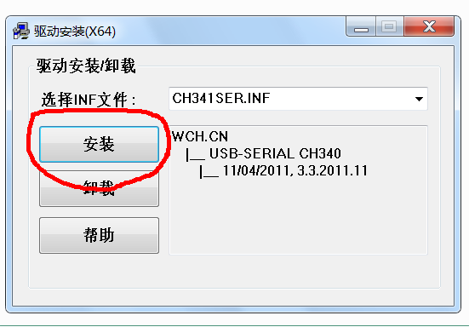

1. Install the driver program

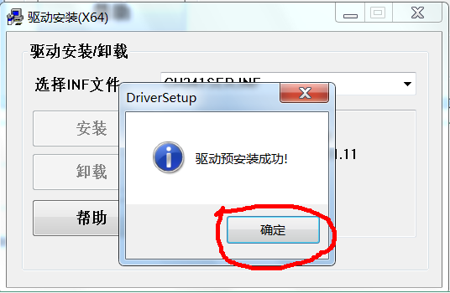

**Ⅳ. Connect the USB uploader with the computer**

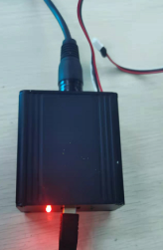

**Ⅴ. Check if the computer can read the USB adapter or not. Please follow the steps as below, back to the desktop, and right-click the logo “computer”, and then left-click the “Management (G)”**

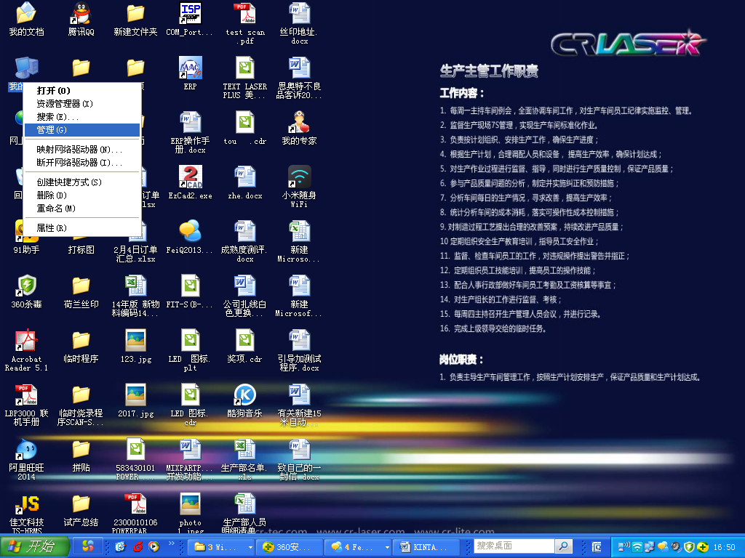

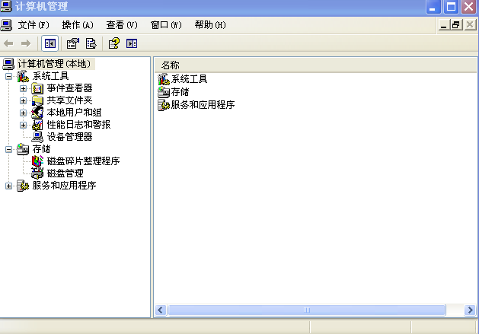

Click the “Device “manager”

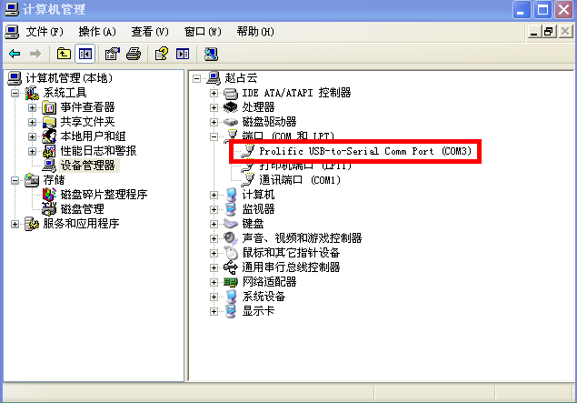

It means the USB uploader has connected with the computer. Pay attention to the port number, it could be COM3, COM4, or any COM number, but the port No. below should be the same as it.

**Ⅵ. Open the ISP software, and follow the steps as below**

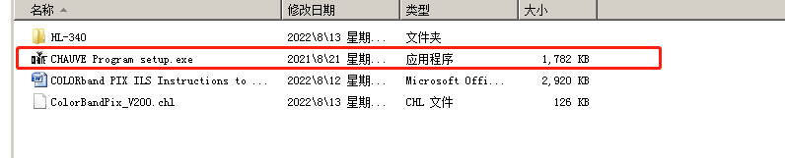

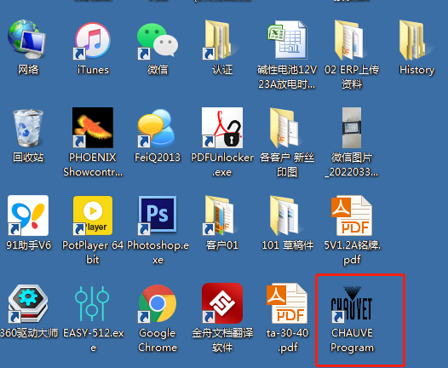

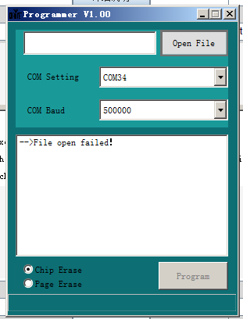

Select the new software

1. Choose the COM port number, it’s “COM34” in this computer

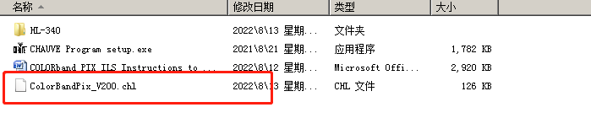

**Ⅶ. Start to refresh the program**

Step1

* Plug in the DMX cable

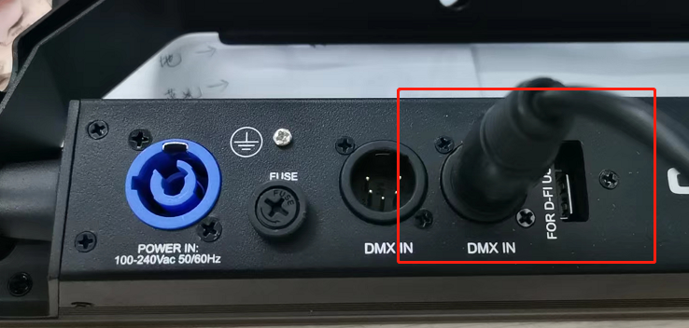

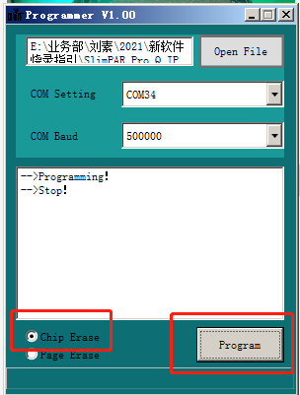

Step 2

Click on the “ PROGRAM”

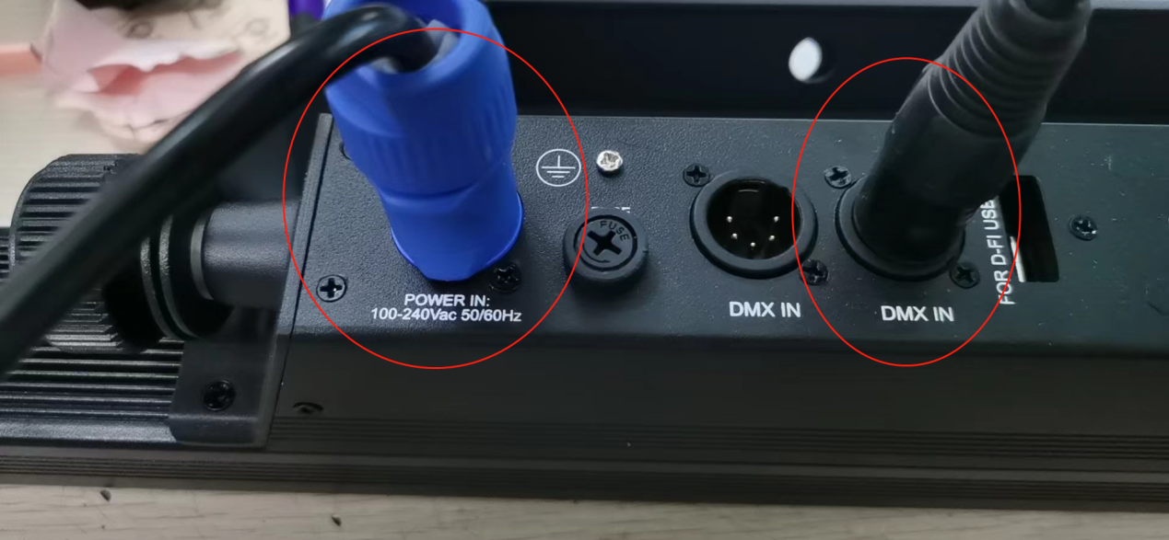

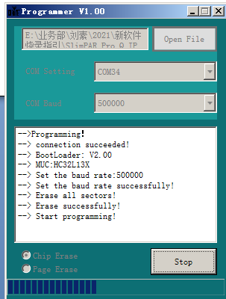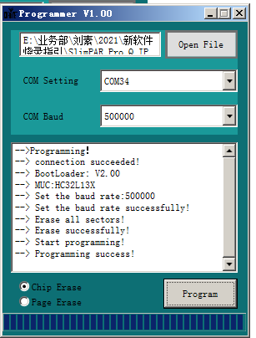

Step3

Power on the unit

Step 4

Updating the fixture